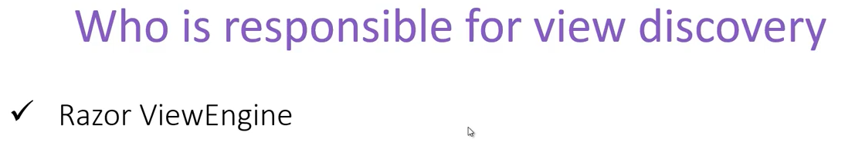

Razor view engine have the configuration for the view discovery. But in case we want to change where our application looks for the view (instead of the default **shared** or **view/{controller}** folder) we need to create our own view engine and we need to define our own settings in the view engine.

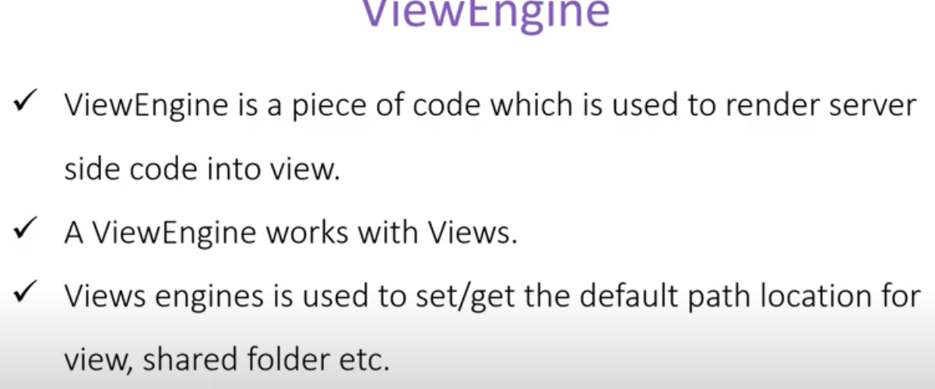

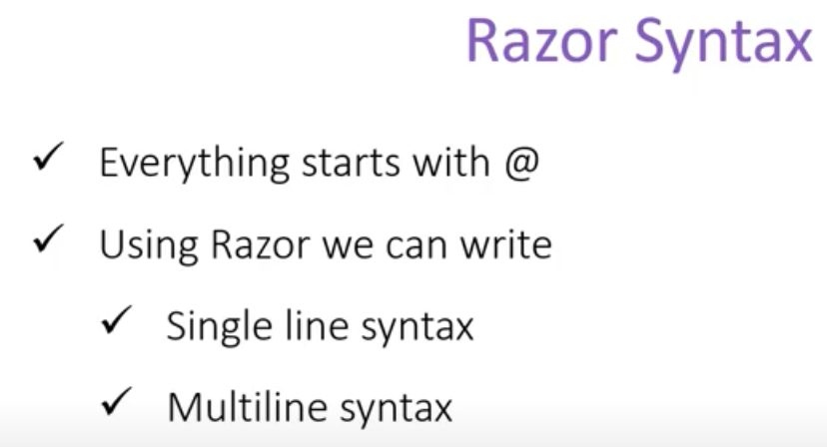

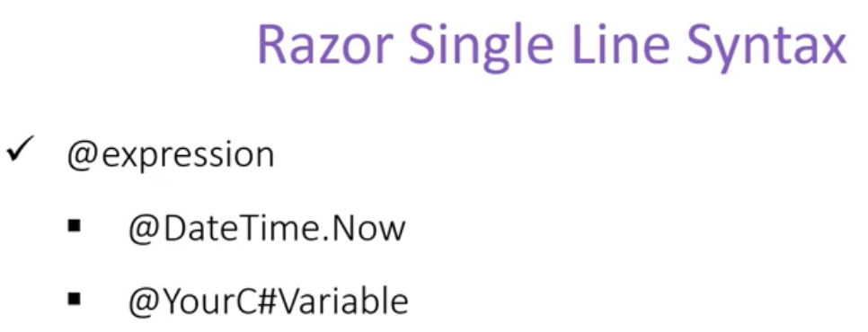

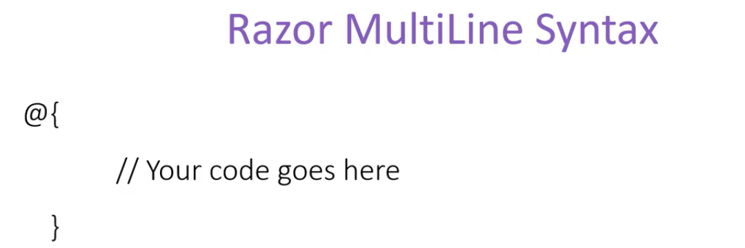

**Escape Sequence:**  in case where we need to use  in our view, we can use another one just before it to escape the code sequence. There is a special case about Email format, for example, [**username@gmail.com**](mailto:username@gmail.com)will not create any error, cause the view engine have it configured/ or we can say is intelligent enough to differentiate.